Could you explain a bit about what Regen does?

Regen is an ealy-stage venture capital firm that backs founders daring to build companies that restore our planet. The mission is to find transformative solutions t oreally big climate problems globally. Our view is that climate issues we face are global poblems with solutions which can come from anywhere. So we are a very globally focussed VC fund with offices in Australia in the Us, investing in early stage start-yps trying to solve thoseproblems. Our investing sweet spot is at the seed stage.

How did you get involved personally at Regen?

I first met the founer, Dan five years ago while I was working at a start-up called Umi, a food waste marketplace here in Australia and was responsible for our fundraising efforts- raising a series A.

We were pitching to Dan, and then we stayed in touch since, and the nat Oxford I was running an organisation called the Oxford Seed Fund, which is a student led VC fund which invests in early stage start-ups at the pre-seed stage. It was there that I backed the first cheque into Go1(https://www.go1.com/en-au/), which is an Australian unicorn now. So I was then reached out to Dan, to get hus thoughts on VC investing and running a fund. During that call, he was telling me about what his plans were for Regen which was just an idea. When he spoke about the ambition and his goal to move a billion dollars of capital into catalytic climate startups over the next 10 years, I just didn't really want to talk about anything else after that And keen to get involved. So I was still in the UK at that point and did a summer internship with Regen, and then finished my degree at Oxford, and then decided to move back to Australia to join Dan and the Regen team full time. Yeah, and since then, it's been an amazing experience, I feel quite fortunate to be part of a fund from day one, which is a really interesting time to be at a fund. So we've got, you know, we've been going through the fundraising process, we subsequently got our first close, made our first couple of investments, and up and running, which is really exciting, and to hiring and growing.

What lessons have you learned so far?

There's probably a couple of hypotheses that we've been able to validate, which has been really exciting. Firstly, there's been a global flow of talent moving into the climate space. So we thought that mission driven founders with a climate mission would have a really unfair advantage in attracting and retaining top tier talent. That was based on some of the trends and studies that we've seen about people wanting to be more mission aligned with their work, particularly the younger generation of workers. So we've seen that played out over and over and in increasing volumes. We've been speaking to founders who have left Google, Facebook, Airbnb, SpaceX, Tesla, and are all flowing into the system, wanting to work on climate, because it's the biggest problem of our generation. If the world isn't inhabitable in 20 to 30 years, then there's not much point in doing anything else. And, you know, it's kind of an interesting global challenge. I don't think there are many other examples where, you know, we've required the whole of the human race to work together for something so large and make such a big change decarbonizing the global economy. So it's a pretty, pretty cool thing to work on. And yeah, we're just saying heaps of talent. And, you know, there's groups like work on climate that are kind of springing up to, to really tap into that, where they're becoming resources for people who are leaving rocket ships and want to work on climate. So that's quite cool as well.

Then the other hypothesis we had was on being globally focused. So I think a lot of the solutions were backing the market is global from day one. So we've seen for us, if we were just geographically restricted in one area, we'd probably only see part of the picture and so it's been really amazing. You know, when you're looking at a small niche like soil carbon which is a relatively nascent field, being able to compare kind of all the top five or 10 Solutions across the globe and, and then make your investment in the one that resonates the most with you is a massive advantage, as opposed to just picking the one that happens to be in the geography that you're domiciled in. The other part of that is how great it is to being able to do that. I guess one of the results of COVID is that everyone is much more comfortable meeting and doing business, and even making investments over zoom, and doing things remotely and working remotely and collaborating across time zones and things like that, it really has seemed to have opened up national borders and the globe to be able to do that stuff. So, so yeah, I think we're kind of fortunate in our timing there. But that those two things have, you know, they're really cool to see.

Question?

Yeah, yeah. I mean, we hope to be able to travel and, and, you know, meet with many more people in person, but at the moment, you know, we're making it work. And in some ways, there's, there's an advantage to that.

Question??

It's hard to kind of narrow your focus, because there's a lot of really cool companies being formed. For us, at the moment, we're exploring the nature based solutions value chain. Net zero doesn't mean zero emissions, it means as low emissions as possible, and then some carbon removal to get us to zero or below And so our options for carbon removal are part of nature based solutions, or industrial solutions. I personally think it will probably need both, but it feels like nature based solutions are a little bit more scalable at the moment. So we think it's a really interesting area, whether we're talking forestry or blue carbon from the ocean, or soil carbon, there are some really interesting options to harness nature and restore how ecosystems can become carbon sinks. There's a bunch of problems to solve across that value chain, from marketplaces, to validation measurement to supporting project developers, helping landowners. So we're seeing a lot of interesting innovation there trying to unlock and scale that market as quickly as possible. I think another is alternative production methods. So synthetic biology and food in particular has really been exploding. Everyone's familiar with the alternative proteins space but, along with meat there is the chocolate, coffee, palm oil, there's cotton, textiles and fashion, in general, there's a lot of things that we produced today in relatively unsustainable ways. A

Theres a huge amount of momentum in the space finding alternative production methods that may be more scalable and better performing and cheaper, but also much better for the planet. So that's super exciting. When you know, we're definitely keen on that, you know, dairy cheese. We've met a company the other day that are looking at cell-based crustaceans. I never realised that lobster and crab farming were so carbon intense for example. So that's quite a cool area too.

Now another trend that we're seeing a lot in at the moment is kind of intersection of FinTech and climate. So there's some huge mega trends that have been happening outside the climate world with retail investors democratising access to equity markets and things like that through platforms like Robin Hood, and obviously, crypto and stuff like that. It feels like there's a heap of kind of momentum and demand for retail investors to access asset classes that they've previously found difficult to invest in.

So, if you look at the portfolio of someone who's relatively wealthy, and nthe sophisticated investor, by legal definition, that often looks different to kind of the typical portfolio here that your retail investors might have.

So democratising access to things like renewable energy infrastructure, to land ownership, to agriculture- we're seeing a lot of momentum there. Also, driven by a lot of consumer demand for moving assets out of areas that aren't mission aligned or vision aligned for them. So, you know, we've seen it at like endowments, and colleges and things like that have divested out of oil, and gas, and fuel. In Australia, we've seen super funds that are popping up that are ethical investors like future super, and things like that. So people are starting Neo banks, for consumers, who don't want their deposit funds, or their savings, funding new coal projects and things like that. At the moment, you have very little control over what loans, you know, when you, when you deposit money in the bank, that doesn't just stay there, the bank uses that to make loans and generate income. And those loans could be anything, right, you have very little control over what to do. So we're seeing people trying to take much more control of that by guaranteeing that they go to climate friendly investments that support, renewable instead of infrastructure, funds, and things like that. So that whole area of kind of FinTech and climate just feels like it's exploding at the moment as well. It’s exciting right because there's a huge amount of retail investment that could be going to better use, and there's also the need for us to scale really proven solutions, like solar and wind just requires a load of capital and a low cost. So it does feel in many ways, like a great match.

What’s next for you guys at Regen VC?

Next for us is continuing to build the Regen firm. We’re looking at a bunch of interesting investments at the moment. We're looking to publish some of our sub-sector theses. We're hiring for a couple of roles so it's a really exciting time. We're very fortunate to be in a position now be able to support amazing founders. We've got some portfolio companies now that we want to help as they kind of hit their next milestones. So, you know, that that's kind of what's next for us. You know, we've got a pretty big goal for the next 10 years. So there's a lot of lots of work today.

What advice might you give to your younger self or someone just starting out on this path?

You know, I think I think it's a great time to get involved in climate tech. It’s the opportunity to work on really exciting problems and really make an impact and it's the time to do it. The next 10 years, the next decade, like on a geological timescale is a millisecond. However, sometimes, there are certain kind of inflection periods in the history of our planet that are really important. This next 10 years is one of those. The IPCC report confirms that. It’s great time to get involved and a great time to work on this. both from an impact perspective, but also from a financial perspective, you know, the guys at Union Square ventures, which is one of the most probably successful venture funds, globally, they just had a huge exit with Coinbase. They've talked about climate being to this decade, what cloud computing was the last decade. There's such a huge need for decarbonisation, and there's such huge momentum from both government and business to get there that it’s going to create trillions of dollars of opportunities. So for anyone who's thinking about starting a business, I couldn't think of a better space to, to build something.

Are there any books?

Drawdow is kind of one of the Bible's that people look at.Otherwise there's a book called 2040, that which is a really positive and optimistic look at what our life could look like in 2040 if we do make some of these changes. The idea is not just to avoid climate catastrophe but as we move better and smarter towards more sustainable production systems, we create a much better way of living and a better quality of life.

From the startup side, I really like the hard thing about hard things by Ben Horowitz, which is a great eye opener for anyone joining into this space so they know what they're getting into.

Then there's some great fiction books as well like Ishmael, and The Monkey Wrench Gang.

Tom McQuillen is an Australian VC fighting to stop the effects of climate change. He currently works at Regen, a venture capital firm which invests in early-stage climate-tech startups. Regen's investing sweet-spot is at the seed stage and the team aims to invest a billion dollars this decade into the next generation of innovative climate companies.

In this edited conversation with Peter Green, Tom spoke about his journey into VC, growth trends in various climate-tech areas and gave some advice for folks starting out on their climate journey.

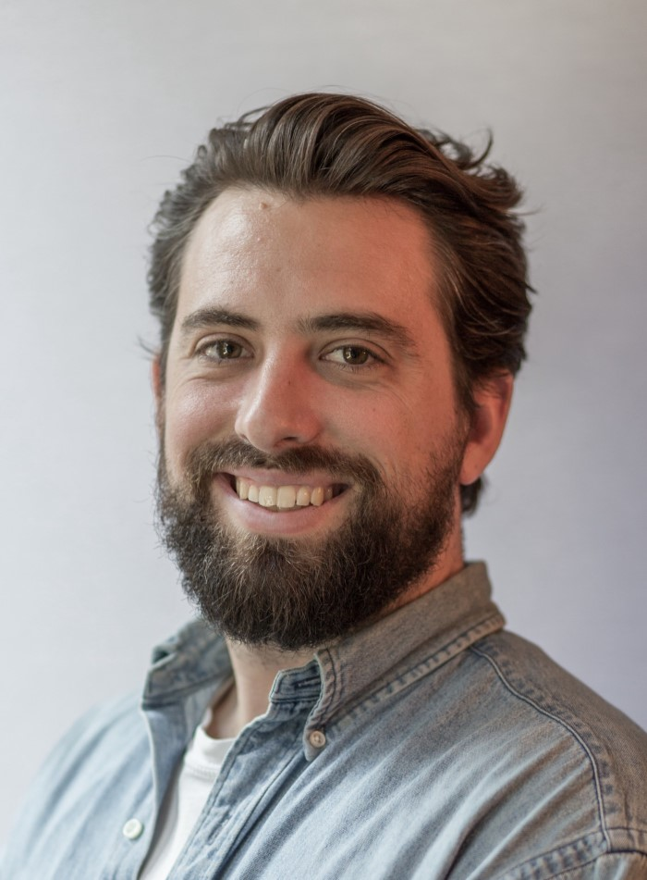

Tom McQuillen (credit Startmate)

**What's the mission at Regen?**

Regen is an early-stage venture capital firm which backs climate-tech founders. Our mission is to find transformative solutions to really big climate problems. We believe climate solutions can come from anywhere. As a result, we are a very globally focussed VC fund with offices in Australia and the US.

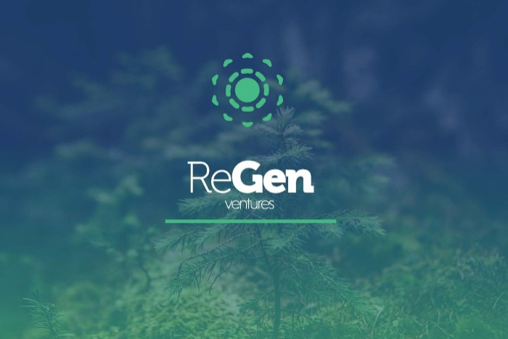

(credit Regen)

**How did you personally get involved at Regen?**

I first met Regen's founder, Dan, five years ago while I was working at a start-up called Yume, a food waste marketplace here in Australia. We stayed in touch while I moved to study at The University of Oxford in the UK. It was there that ran an organisation called the Oxford Seed Fund. This is a student led VC fund which invests in early stage start-ups at the pre-seed stage.  
  
After that, I reached out once more to Dan to get his thoughts on VC investing and running a fund. During that call he told me about his plans for Regen. When he spoke about his ambition and the goal to move a billion dollars of capital into catalytic climate startups over the next 10 years, I didn't want to talk about anything else. I wanted to get involved so I decided to do a summer internship with Regen and finish my degree at Oxford.  
  
I then decided to move back to Australia to join Dan and the Regen team full-time. It's been an amazing experience and I feel very fortunate.

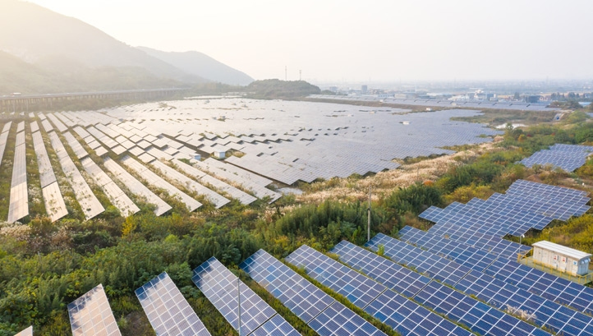

**What important lessons have you learned so far from your time at Regen?**

There are a couple of hypotheses we made a while ago that we've been able to validate recently. Firstly, there's been a global flow of talent moving into the climate space. We thought that mission driven founders with a climate idea would have a really unfair advantage in attracting and retaining top tier talent.  
  
We've seen that play out over and over and in ever-increasing volume. For example, we've been speaking to founders who have left the likes of Google, Facebook, Airbnb, SpaceX and Tesla to work on climate because it's the biggest problem of our generation.  
  
The other hypothesis we made relates to our global focus. A lot of the solutions we back are global from day one. So if we were geographically restricted to one area, we'd probably only see part of the picture. When you're looking at a niche like soil carbon for example, a relatively nascent field, being able to compare the top five or ten solutions across the globe before investing is a massive advantage. Otherwise you'd just be picking the one solution that happens to be in the area that you're domiciled in.  
  
One of the results of COVID is that everyone is more comfortable meeting, doing business, and even making investments online. So I think we've been fortunate in our timing there.

**Which areas of climate-tech have seen the most forward momentum in your opinion?**

It's hard to narrow the focus on one area because there are a lot of really cool companies being formed. At the moment at Regen we're exploring the nature-based solutions value chain. Net zero doesn't mean zero emissions, it means as low emissions as possible, and then some carbon removal to get us below zero. As a result, the options for carbon removal are either made up of nature-based solutions, or industrial solutions.  
  
Personally I think we will need both, but it feels like nature-based solutions are a little bit more scalable at the moment. Whether we're talking forestry, blue carbon from the ocean, or soil carbon there are some really interesting options to harness nature and restore the way ecosystems act as carbon sinks. On that front, there are plenty of problems to solve across the value chain. We need marketplaces, validation, measurement techniques, and ways to support project developers and landowners. We're seeing a lot of interesting innovation there trying to unlock and scale that market as quickly as possible.

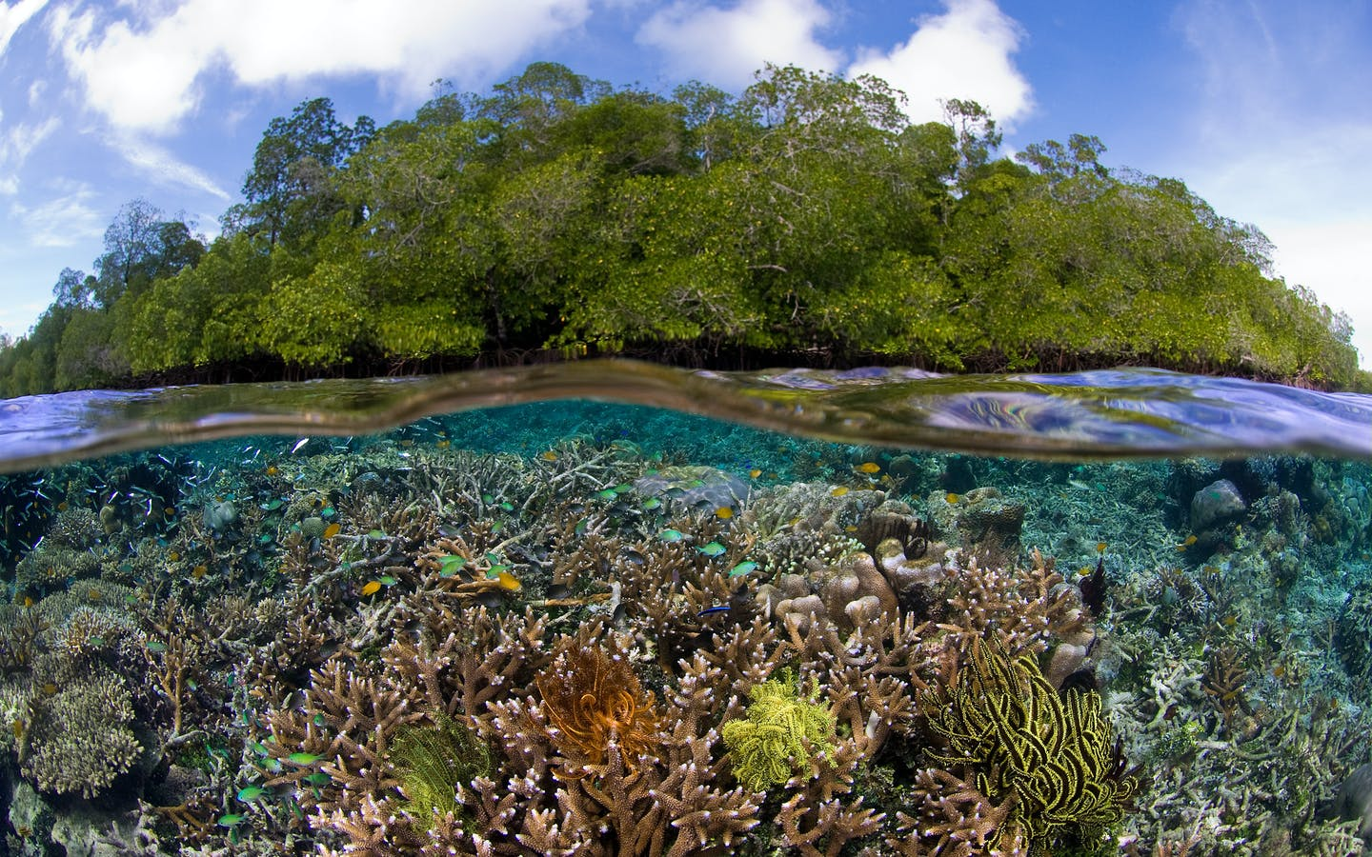

Blue Carbon

Another interesting area relates to alternative production methods. Everyone's familiar with the alternative protein space but, aside from meat, there are products including chocolate, coffee, palm oil, cotton and textiles which all need to be produced more sustainably. There's a huge amount of momentum in the alternative production space which is super exciting.  
  
Now another trend that we're seeing lies at the intersection between fintech and climate. There are some huge megatrends that have been happening outside the climate world such as retail investors democratising access to equity markets. There's a lot of momentum and demand for retail investors to access asset classes that they've previously found difficult to invest in. This includes the democratisation of access to renewable energy infrastructure, land ownership, and agriculture.  
  
There is also a lot of consumer demand to move assets out of unsustainable areas. For example, people are starting Neobanks for consumers who don't want their savings funding new coal projects for example. It’s exciting because there's a huge amount of retail investment that could be going to better use, and there's also the need for us to scale really proven solutions like solar and wind which require plenty of capital.



**What’s next for you guys at Regen VC?**

We're continuing to build the Regen firm. We’re looking at a bunch of interesting investments at the moment and hoping to publish some of our sub-sector theses. We're also hiring for a couple of roles and are very fortunate to be able to support some amazing founders in reaching their next milestones.

**What advice might you give to your younger self or someone just starting out on this path?**

I think it's a great time to get involved in climate-tech both from an impact perspective, but also from a financial perspective. The next 10 years on a geological timescale is a millisecond but is a critical inflection period in the history of our planet's climate. The IPCC report confirms that and shows that there's a huge need for decarbonisation. There's also such massive momentum from both government and business to get there that it’s going to create trillions of dollars of opportunities. So for anyone who's thinking about starting a business, I couldn't think of a better space to build something. On the one hand through social media like [Twitter](https://twitter.com/satgana_), [LinkedIn](https://www.linkedin.com/company/satgana/), and [Instagram](https://www.instagram.com/satgana_/?hl=en). On the other hand we're building partnerships and collaborating with some really interesting organisations in the sustainability space.

**What books might you recommend to someone who's trying to build ventures in this space?**

["Drawdown"](https://twitter.com/satgana_) is always worth mentioning. Otherwise there's a book called ["2040"](https://twitter.com/satgana_) which is a really positive and optimistic look at what our life could look like in 2040 if we make some of these changes. The idea is not just to avoid climate catastrophe but also to create a better way of living as we approach better production systems. From the startup side, I really like ["The Hard Thing About Hard Things"](https://www.goodreads.com/book/show/18176747-the-hard-thing-about-hard-things) by Ben Horowitz, which is a great eye opener for anyone moving into this space so they know what they're getting into. Finally I'd recommend some great fiction books as well like ["Ishmael"](https://www.goodreads.com/book/show/40611328-ishmael), and ["The Monkey Wrench Gang."](https://www.goodreads.com/book/show/99208.The_Monkey_Wrench_Gang)